# Beef - pasture-raised and organic products

If you're seeking high-quality pasture-raised and organic beef, several reputable brands are known for their commitment to sustainable and humane farming practices. Here are some notable options:

**TruBeef Organic**Offers 100% organic, grass-fed, and grass-finished beef raised on wild pastures year-round. Their cattle are pasture-raised without hormones, antibiotics, or GMOs, emphasizing regenerative and sustainable farming practices.

[Tru Organic Beef](https://truorganicbeef.com/?utm_source=chatgpt.com)

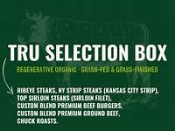

**Crowd Cow**Provides grass-fed and grass-finished beef sourced from independent farms that prioritize humane and sustainable practices. They offer transparency about their sourcing, allowing consumers to know the origins of their meat.

[Wikipedia](https://en.wikipedia.org/wiki/Crowd_Cow?utm_source=chatgpt.com)

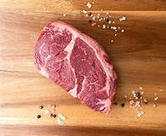

**ButcherBox**Delivers 100% grass-fed and grass-finished beef, free-range organic chicken, and heritage-breed pork. Their meats are antibiotic-free and hormone-free, sourced from farms dedicated to humane and sustainable practices.

[Everyday Easy Eats](https://www.everydayeasyeats.com/best-sources-for-organic-meat-delivery/?utm_source=chatgpt.com)

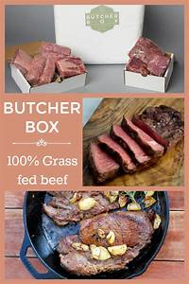

**White Oak Pastures**A family-owned farm offering grass-fed beef from cattle raised on organic pastures. They practice regenerative agriculture and operate their own on-site processing facilities to ensure quality and humane treatment.

[Wikipedia](https://en.wikipedia.org/wiki/White_Oak_Pastures?utm_source=chatgpt.com)

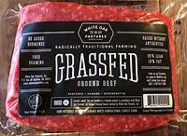

**Primal Pastures**Provides beyond organic, pasture-raised, corn- and soy-free meats, including grass-fed beef. Their commitment to sustainable farming ensures high-quality products delivered nationwide.

[Primal Pastures](https://primalpastures.com/?utm_source=chatgpt.com)

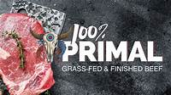

These brands are recognized for their dedication to providing consumers with beef that is both ethically raised and environmentally sustainable.

If you're interested in exploring more pasture-raised and organic beef options, here are some additional reputable brands known for their commitment to quality and sustainable farming practices:

**Verde Farms**Offers USDA organic, 100% grass-fed, and grass-finished beef. Their cattle roam freely on pastures and are raised without hormones or antibiotics.

[Verde Farms](https://verdefarms.com/?utm_source=chatgpt.com)

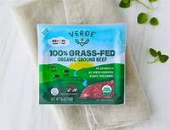

**Organic Prairie**Provides USDA certified organic beef, chicken, pork, and turkey from family farms. Their animals are pasture-raised, and products are delivered directly to your doorstep.

[Organic Prairie](https://www.organicprairie.com/?utm_source=chatgpt.com)

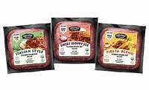

**Seven Sons Farms**Offers 100% grass-fed beef, lamb, and bison, as well as pasture-raised pork and chicken. They emphasize ethical raising practices and regenerative farming.

[Seven Sons](https://sevensons.net/?utm_source=chatgpt.com)



**Wild Pastures**Provides pasture-raised beef, pork, and chicken without hormones or antibiotics. They focus on rotational grazing and regenerative farming practices.

[Wild Pastures](https://wildpastures.com/?utm_source=chatgpt.com)

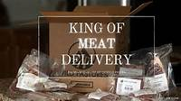

**Thousand Hills Lifetime Grazed**Specializes in 100% grass-fed and grass-finished beef, with cattle always on pasture, managed holistically to regenerate soil and grasslands.

[Thousand Hills Lifetime Grazed](https://thousandhillslifetimegrazed.com/grass-fed-beef/?utm_source=chatgpt.com)

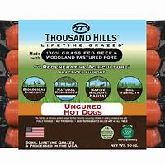

These brands are dedicated to providing high-quality, sustainably raised beef, ensuring that consumers have access to nutritious and ethically produced meat options.

Whole Foods Market offers a variety of pasture-raised and organic beef products that adhere to their stringent quality standards. While specific brand availability can vary by location, here are some notable brands and products you might find:

**Eel River Organic Beef**Provides USDA-certified organic, grass-fed, and grass-finished beef. Their cattle are raised without the use of hormones or antibiotics, ensuring high-quality meat.

[Whole Foods Market](https://www.wholefoodsmarket.com/products/meat/beef?utm_source=chatgpt.com)

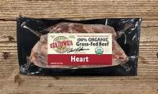

**Dakota Grass-Fed Beef**Offers premium organic beef from cattle that are 100% grass-fed and grass-finished, raised without added hormones or antibiotics. Their products include steaks, ground beef, and more.

[Wikipedia](https://en.wikipedia.org/wiki/Dakota_Beef?utm_source=chatgpt.com)

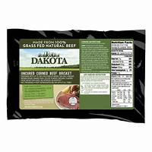

**Verde Farms**Specializes in USDA organic, 100% grass-fed, and grass-finished beef. Their cattle roam freely on pastures and are never given antibiotics or added hormones.

[Verde Farms](https://verdefarms.com/?utm_source=chatgpt.com)

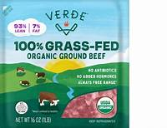

**Organic Prairie**Provides USDA-certified organic beef from family farms. Their cattle are pasture-raised without the use of synthetic fertilizers, pesticides, or GMOs.

[Organic Prairie](https://www.organicprairie.com/?utm_source=chatgpt.com)

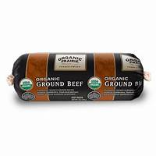

**Crowd Cow**Offers grass-fed and grass-finished beef sourced from independent farms that prioritize humane and sustainable practices. Their products are free from added hormones and unnecessary antibiotics.

[Wikipedia](https://en.wikipedia.org/wiki/Crowd_Cow?utm_source=chatgpt.com)

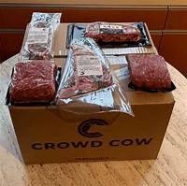

It's important to note that Whole Foods Market maintains rigorous meat quality standards, ensuring that all beef sold in their stores meets specific criteria, including no added hormones and adherence to animal welfare standards.

[Whole Foods Market](https://www.wholefoodsmarket.com/quality-standards/meat-standards?utm_source=chatgpt.com)

For the most accurate and up-to-date information on available brands and products, it's recommended to contact your local Whole Foods Market directly or visit their official website.

Sources

Favicon

Favicon

Favicon

Favicon

##### **You said:**

what pasture raised and organic beef brands are sold at outpost Natural foods in Milwaukee

###### **ChatGPT said:**

ChatGPT

Outpost Natural Foods in Milwaukee is dedicated to offering high-quality, naturally raised meats, including pasture-raised and organic beef. While specific brand availability can vary, here are some notable suppliers and brands associated with Outpost:

**Wisconsin Meadows Beef**Provided by the Wisconsin Grass-fed Beef Cooperative, Wisconsin Meadows offers 100% grass-fed beef from cattle raised on a natural diet without antibiotics or hormones.

[Outpost](https://outpost.coop/shop/departments/meat_and_seafood/?utm_source=chatgpt.com)

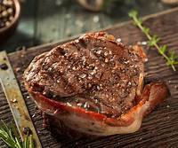

**Organic Prairie**As part of the Organic Valley cooperative, Organic Prairie offers USDA-certified organic beef from cattle raised without synthetic fertilizers, pesticides, or GMOs.

[Wikipedia](https://en.wikipedia.org/wiki/Organic_Valley?utm_source=chatgpt.com)



**Alden Hills Organic Farms**A family-owned certified organic farm in Walworth, Wisconsin, Alden Hills produces grass-fed beef and is known to supply local markets, potentially including Outpost Natural Foods.

[Milwaukee Magazine](https://www.milwaukeemag.com/8-certified-organic-wisconsin-farms-to-check-out/?utm_source=chatgpt.com)

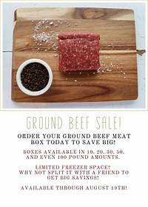

Outpost emphasizes transparency in sourcing, ensuring that their meats are free from antibiotics, hormones, and growth-enhancing drugs. They prioritize relationships with local and regional farmers who adhere to sustainable and humane farming practices.

[Outpost](https://outpost.coop/shop/departments/meat_and_seafood/?utm_source=chatgpt.com)